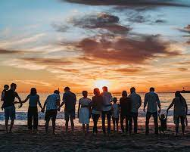
San Juan Catholic Community

Faith Formation – Families Forming Disciples

2022 -2023

Schedule of Topics and Dates
The first session of each month take place at St. Joseph’s at 6:00 pm. The second session take place in the homes. The third session take place on-line by Zoom. (Main topics are in bold, subtopics are in italics.)

September 18
The Bible
God’s Revelation
Sacred Scripture, Sacred Tradition
The Bible is a Catholic Library
October 16
Creation
The goodness of Creation
Covenantal History and Promises
November 13
The Fall and Promise of Redemption
New Adam – Jesus
New Eve – Mary
December 11
God’s Covenant with Noah
Covenants and Sacraments
January 8
God’s Covenant with Abraham
The Promise to Abraham
From a family to 12 Tribes

February 5
God’s Covenant with Moses
Exodus and Passover
Covenant at Sinai
10 Commandments
March 5
Jesus the New Moses, the Rescuer
Last Supper, Eucharist
Mary, the Ark of the New Covenant
April 2
God’s Covenant with David
Jesus, Descendent of David, King
Jesus, the Good Shepherd
April 23
Mary and Israel
Old Testament Prophets
Mary ‘s Fiat
New Covenant in Jesus

