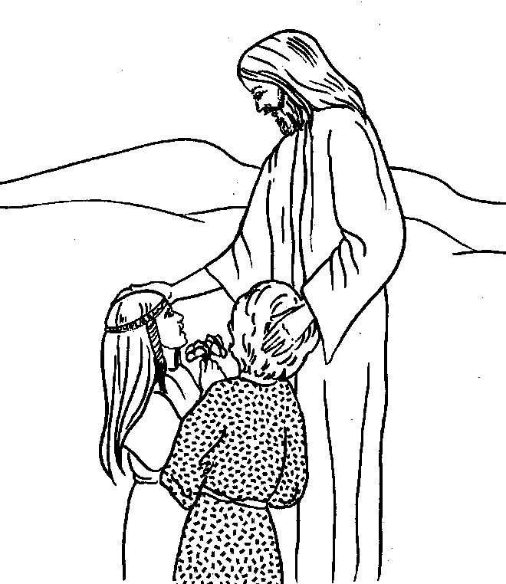
San Juan Catholic Community

Faith Formation – Families Forming Disciples

2022 -2023

Our Mission
We, the catechists and clerical team of the San Juan Catholic Community, are committed to supporting families in their baptismal promise to raise their children in our faith. We believe that children and youth are formed as disciples of Christ within their families. Solid Catholic families are where saints are formed. The catechists, with the support of our parish administrator, are focused on collaborating with parents in the formation of disciples and saints for Christ.

Our Guiding Understandings
Our mission is based on the following understandings:
- We believe that now, more than ever, children, youth, and their families ‘hunger’ for a profound relationship with Jesus Christ.
- We honor and support parents in the promise to raise their children in our faith.
- The family, which is the domestic church, is a holy unit. The domestic church is where parents, the first catechists, share our faith in a real and living manner.
- Our country and global community thrive when we have a real and living relationship with Jesus and His Church.
- We cannot continue to do what we have historically done and expect to form vibrant disciples for Christ.
- The Sunday Celebration of the Eucharist, Mass, is where we are fed with the Word and Holy Communion.

Our Plan
For three years, we have used a home-based form for catechism. We did this to keep the people we serve healthy during the Covid pandemic. We came to appreciate in a greater way the importance of forming children and youth within the context of their families. We began using materials that were never designed for home-based catechesis. Last year, we used web-based materials that are specifically designed for forming disciples within the context of their families. We have been very pleased with the materials and delivery of Families Forming Disciples.

Families Forming Disciples was developed by the Archdiocese of Atlanta. It is based upon professionally produced lessons for families, all members of the families. It is prayerful, it includes a variety of learning media, and it is moves families through the liturgical calendar. The first lesson of each month presents the key concepts and focus for the month. The second lesson of each month is a home mission activity. Parents guide the family in an activity related to the focus of the month. The third session of each month is a review of the focus and a sharing of the home mission activity.

In our formation process, we will present the first session, the key session, in person in Spanish and English. We will gather at St. Joseph’s in Monte Vista for prayer then break out into our language groups for the lesson focus. Children and youth that are preparing for Sacraments are required to attend these sessions. During the first session, directions and materials will be shared for the second monthly session, the home mission activity. Parents will lead their families in the home mission activity. The third session of each month will be done on-line via Zoom. Small communities of families will gather to review the key concepts of the month and discuss their home mission activity.

Small faith communities will be formed. Families will be assigned a pair of catechists who will provide direct support and answer questions. They will be available to answer questions by phone, text, or email. Each small faith community will meet with their catechist for the third session, the review session. The small faith communities will be assigned by relationships and language (Spanish or English).

Sacramental Formation

Families that would like their children to prepare for the Sacraments of Reconciliation, First Eucharist, and Confirmation will need to submit an application for that specific Sacrament. The reception of the Sacraments is NOT based on age, number of years in catechism, or age of the person. The reception of the Sacraments depends upon their readiness. In a discernment interview, the pastor, parish administrator, or his designee will discern the readiness of each applicant. Some students will receive the Sacrament after one year of formation, while others may require two or three years of formation. This is required by the Diocesan Guidelines, approved by our bishop in July of 2019.

Parents are the primary catechists of their children, and this includes the Sacraments of Reconciliation and First Eucharist. The materials that we used for preparing students for these Sacraments are family based and interactive. They incorporate family prayer, instruction, games, and active learning. Children will use Mend to prepare for the Sacrament of Reconciliation and Nourish for the Sacrament of First Eucharist. Each set of materials comes in a kit with all the necessary materials, and lesson plans for the parents. Mend contains seven lessons and Nourish contains ten lessons. Catechists will provide the kits. Parents will be responsible for the fee.

Those students that are preparing for the Sacrament of Confirmation will attend a series of sessions in person along with their parents and, when feasible, their sponsor. A retreat experience is required for all Confirmation candidates.

Everyone that is preparing for a Sacrament is required to participate in 90% of the Families Forming Disciples sessions.

Confirmation students will be required to complete liturgical service hours and non-liturgical service hours. That is, they are required to assist at Mass as a lector, usher, altar server or minister of hospitality. Non-liturgical service takes place outside of the Mass. Candidates may assist others, such as the elderly or children. They can participate in parish activities, and in other approved ways.

Last year was a memorable year. We are pleased with the interactions and results of last year’s use of Families Forming Disciples. Parents, catechists, and clergy are excited to begin. We thank God that you have responded well to Families Forming Disciples. It is an honor to serve the families of the San Juan Catholic Community and we are eager to collaborate with you in the formation of your children and youth. You can count on our support. Please feel free to contact us with your questions.

